1. Introduction to SQL

**LAB EXERCISES**: Create a database called library_db and a table books with columns: b

• **Lab 3**: book_id, title, author, publisher, year_of_publication, and price. Insert five records into the table.

* CREATE DATABASE library_db;
* Create the books table
  + CREATE TABLE books (
  + book_id INT AUTO_INCREMENT PRIMARY KEY,
  + title VARCHAR (255),
  + author VARCHAR(255),
  + publisher VARCHAR (255),
  + year_of_publication INT,
  + price DECIMAL (10, 2)

);

* INSERT INTO books (title, author, publisher, year_of_publication, price)

VALUES

('The Great Gatsby', 'F. Scott Fitzgerald', 'Charles Scribner\'s Sons', 1925, 10.99),

('To Kill a Mockingbird', 'Harper Lee', 'J.B. Lippincott & Co.', 1960, 7.99),

('1984', 'George Orwell', 'Secker & Warburg', 1949, 8.99),

('Pride and Prejudice', 'Jane Austen', 'T. Egerton', 1813, 6.99),

('Moby-Dick', 'Herman Melville', 'Harper & Brothers', 1851, 9.99);

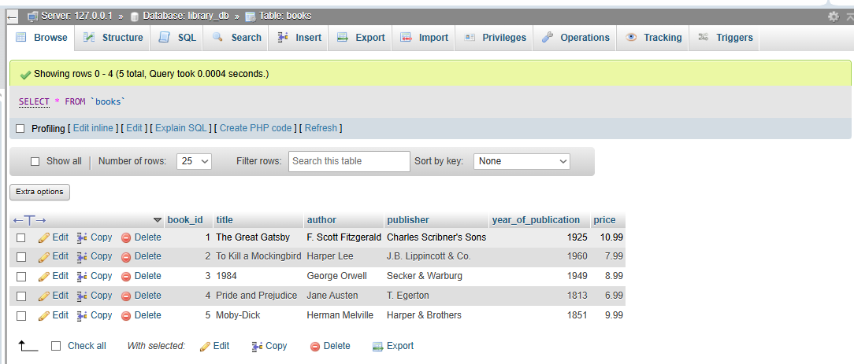

• **Lab 4**: Create a table member in library_db with columns: member, member name,

date_of_membership, and email. Insert five records into this table.

* CREATE TABLE members (

member_id INT AUTO_INCREMENT PRIMARY KEY,

member_name VARCHAR(100),

date_of_membership DATE,

email VARCHAR(100)

);

* INSERT INTO members (member_name, date_of_membership, email)

VALUES

('Harshani Patil', '2023-01-15', 'harshani.patil@example.com'),

('Krunal Patel', '2023-03-10', 'krunal.patel@example.com'),

('Ruchi Patil', '2023-05-22', 'Ruchi.Patil@example.com'),

('Nidhi Mehta', '2023-07-30', 'Nidhi.Mehta@example.com'),

('Kajal Jain', '2023-09-05', 'kajal.Jain@example.com');

('Rits Patil', '2021-11-12', 'rits.patil@example.com');

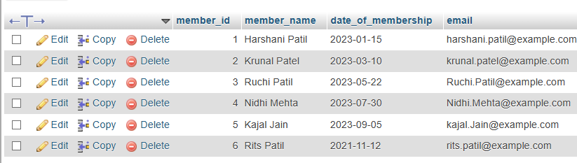

2. SQL Syntax

**LAB EXERCISES**:

• **Lab 3**: Retrieve all members who joined the library before 2022. Use appropriate SQL syntax with WHERE and ORDER BY.

* SELECT * FROM members WHERE date_of_membership < '2022-01-01' ORDER BY date_of_membership ASC;

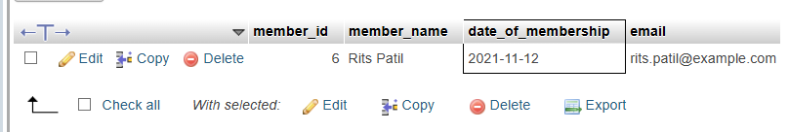

• **Lab 4**: Write SQL queries to display the titles of books published by a specific author. Sort the results by year_of_publication in descending order.

* SELECT title FROM books WHERE author = 'George Orwell’ ORDER BY year_of_publication DESC;

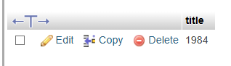

3. SQL Constraints

**LAB EXERCISES**:

• **Lab 3**: Add a CHECK constraint to ensure that the price of books in the books table is greater than 0.

* ALTER TABLE books ADD CONSTRAINT chk_price_positive CHECK (price > 0);

**Show Constraints in MySQL**

* SELECT CONSTRAINT_NAME, TABLE_NAME, CONSTRAINT_TYPE FROM information_schema.TABLE_CONSTRAINTS WHERE TABLE_SCHEMA = 'library_db' AND TABLE_NAME = 'books';

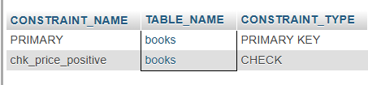

• **Lab 4**: Modify the members table to add a UNIQUE constraint on the email column, ensuring that each member has a unique email address.

* ALTER TABLE members ADD CONSTRAINT unique_email UNIQUE (email);
* SHOW INDEX FROM members;

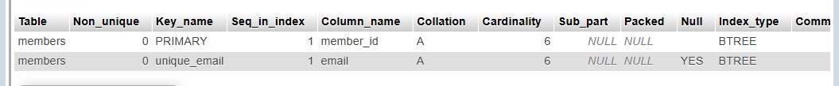

4. Main SQL Commands and Sub-commands (DDL)

**LAB EXERCISES**:

• **Lab 3**: Create a table authors with the following columns: author_id, first_name,

last_name, and country. Set author_id as the primary key.

* CREATE TABLE authors ( author_id INT AUTO_INCREMENT PRIMARY KEY, first_name VARCHAR(50), last_name VARCHAR(50),country VARCHAR(70));

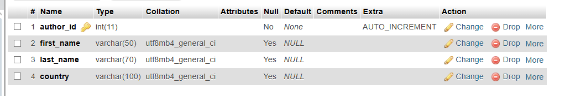

• **Lab 4**: Create a table publishers with columns: publisher_id, publisher_name, contact_number, and address. Set publisher_id as the primary key and contact_number as unique.

* CREATE table publishers (publisher_id int AUTO_INCREMENT PRIMARY KEY, publisher_name varchar (50), contact_number varchar (50), address varchar (50));

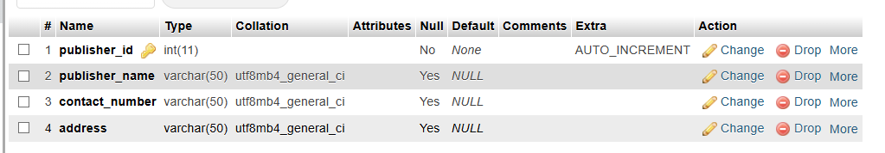

5. ALTER Command

**LAB EXERCISES**:

• **Lab 3**: Add a new column genre to the books table. Update the genre for all existing records.

* ALTER TABLE books ADD COLUMN genre VARCHAR(100);
* UPDATE books SET genre = 'Fiction' WHERE title = 'To Kill a Mockingbird';
* UPDATE books SET genre = 'Science Fiction' WHERE title = 'Dune';
* UPDATE books SET genre = 'Fantasy' WHERE title = 'Harry Potter and the Sorcerer''s Stone';
* UPDATE books SET genre = 'Historical' WHERE title = 'The Book Thief';

-- Add more UPDATE statements based on the actual titles in your table

* UPDATE books SET genre = 'Unknown';

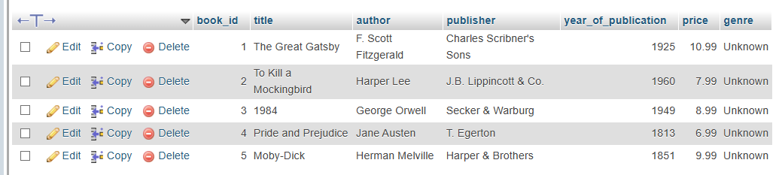

• **Lab 4**: Modify the members table to increase the length of the email column to 100 characters.

* ALTER TABLE members MODIFY COLUMN email VARCHAR (100);

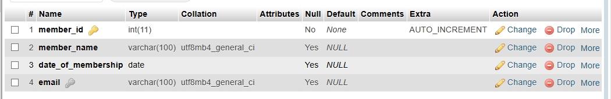

6. DROP Command

**LAB EXERCISES**:

• **Lab 3**: Drop the publishers table from the database after verifying its structure.

* DESCRIBE publishers;

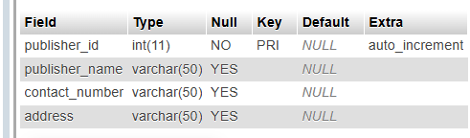

* [DROP](http://localhost/phpmyadmin/url.php?url=https://dev.mysql.com/doc/refman/8.0/en/drop-table.html) [TABLE](http://localhost/phpmyadmin/url.php?url=https://dev.mysql.com/doc/refman/8.0/en/drop-table.html) publishers;

• **Lab 4**: Create a backup of the members table and then drop the original members’ table.

* [SELECT](http://localhost/phpmyadmin/url.php?url=https://dev.mysql.com/doc/refman/8.0/en/select.html) * FROM `members_backup`

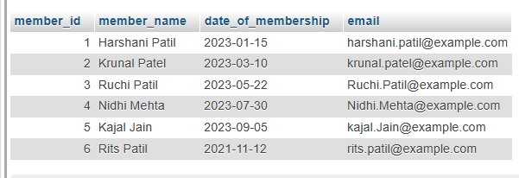

* DROP TABLE members;

7. Data Manipulation Language (DML)

**LAB EXERCISES**:

• **Lab 4**: Insert three new authors into the authors table, then update the last name of one of the authors.

* INSERT INTO authors (first_name, last_name, country) VALUES ('Anita', 'Desai', 'India'), ('Chetan', 'Bhagat', 'India'), ('Jhumpa', 'Lahiri', 'USA');

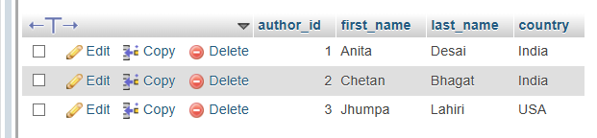

* UPDATE authors SET last_name = 'Mehta' WHERE first_name = 'Chetan' AND last_name = 'Bhagat';

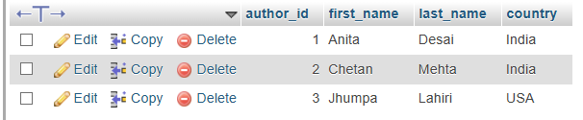

• **Lab 5**: Delete a book from the books table where the price is higher than $100.

* DELETE FROM books WHERE price > 100;

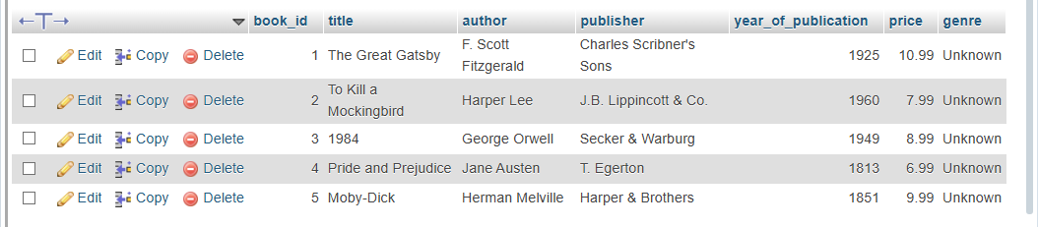

8. UPDATE Command

**LAB EXERCISES**:

• **Lab 3**: Update the year_of_publication of a book with a specific book_id.

* UPDATE books SET year_of_publication = 2022 WHERE book_id = 5;

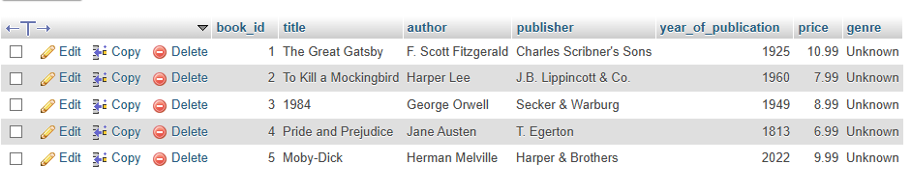

• **Lab 4**: Increase the price of all books published before 2015 by 10%.

* UPDATE books SET price = price * 1.10 WHERE year_of_publication < 2015;

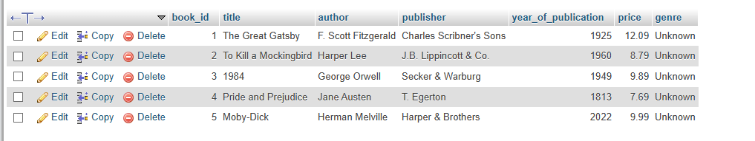

9. DELETE Command

**LAB EXERCISES**:

• **Lab 3**: Remove all members who joined before 2020 from the members table.

* DELETE FROM members WHERE date_of_membership < '2020-01-01';
* SELECT * FROM members WHERE date_of_membership < '2020-01-01';

• **Lab 4**: Delete all books that have a NULL value in the author column.

* DELETE FROM books WHERE author IS NULL;
* SELECT * FROM books WHERE author IS NULL;

10. Data Query Language (DQL)

**LAB EXERCISES**:

• **Lab 4**: Write a query to retrieve all books with price between $50 and $100.

* SELECT * FROM books WHERE price BETWEEN 50 AND 100;

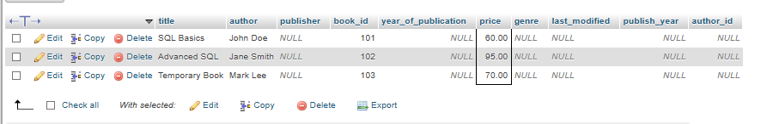

• **Lab 5**: Retrieve the list of books sorted by author in ascending order and limit the results to the top 3 entries.

* SELECT * FROM books ORDER BY author ASC LIMIT 3;

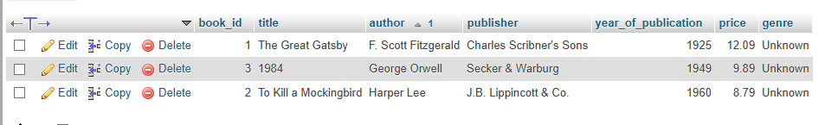

11. Data Control Language (DCL)

**LAB EXERCISES**:

• **Lab 3**: Grant SELECT permission to a user named librarian on the books table.

* GRANT SELECT ON books TO librarian;

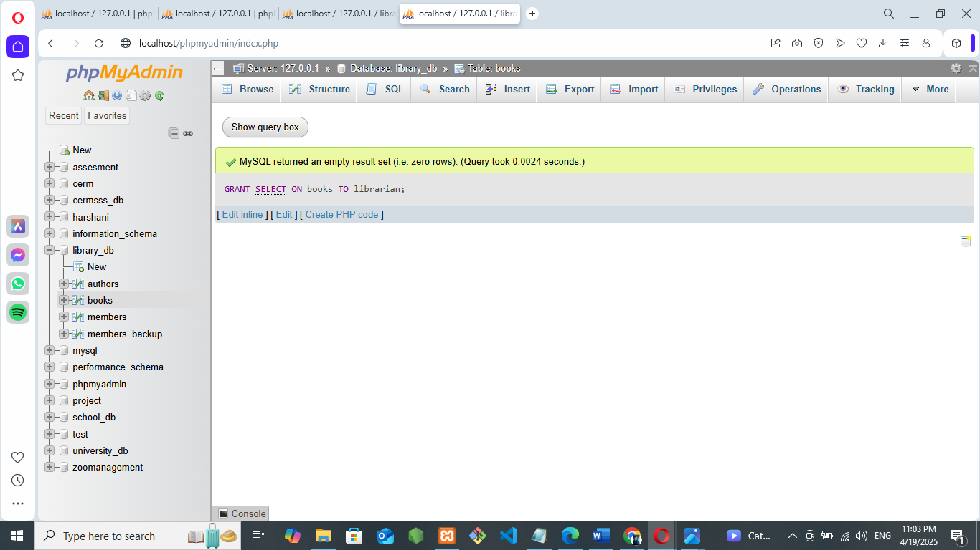

• **Lab 4**: Grant INSERT and UPDATE permissions to the user admin on the members table.

* GRANT INSERT, UPDATE ON members TO admin;

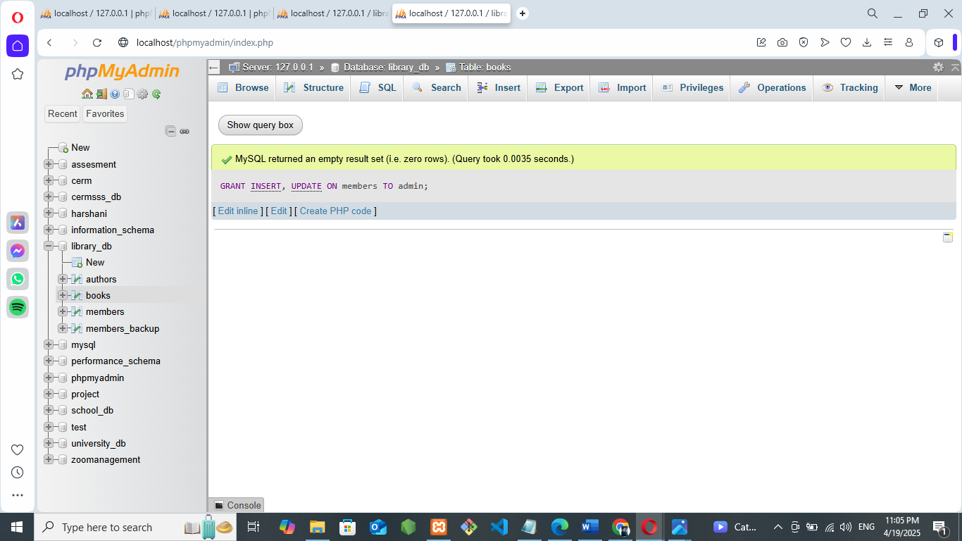

12. REVOKE Command

**LAB EXERCISES**:

• **Lab 3**: Revoke the INSERT privilege from the user librarian on the books table.

* REVOKE INSERT ON books FROM librarian;

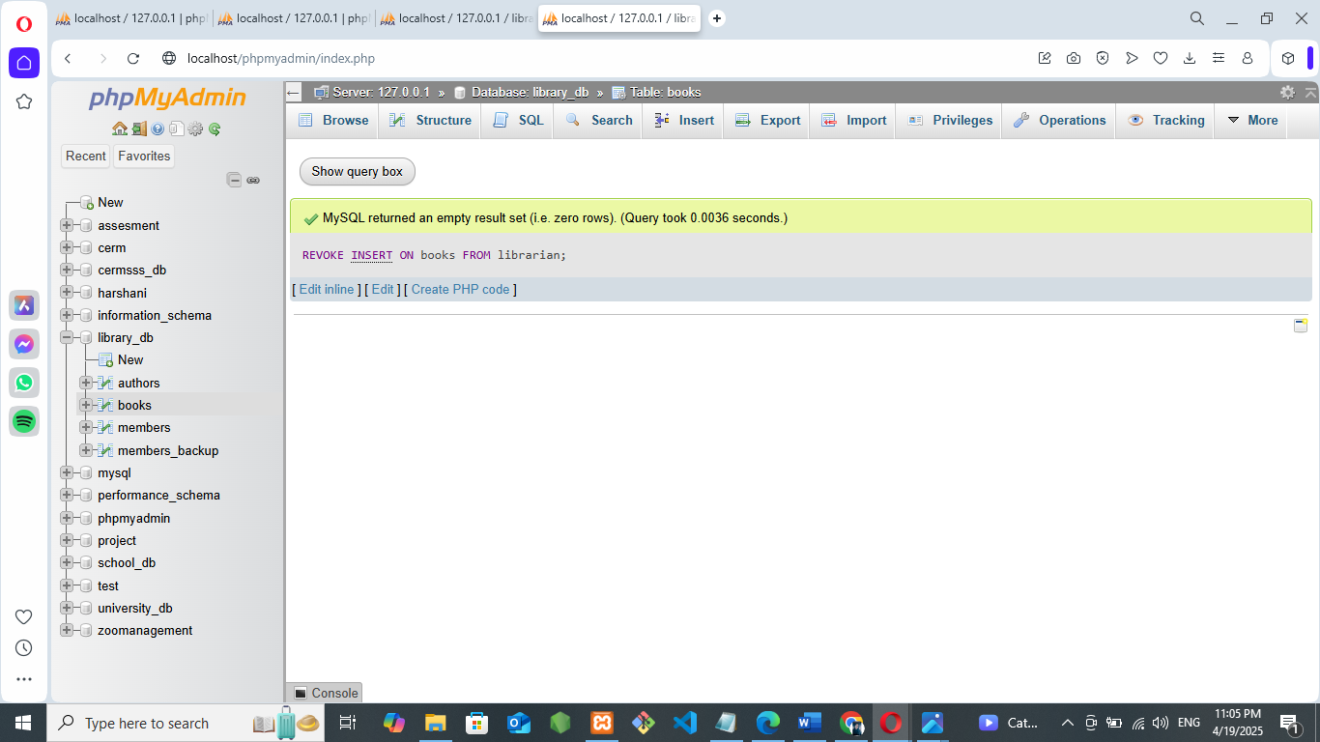

• **Lab 4**: Revoke all permissions from user admin on the members table.

* REVOKE ALL PRIVILEGES ON members FROM admin;

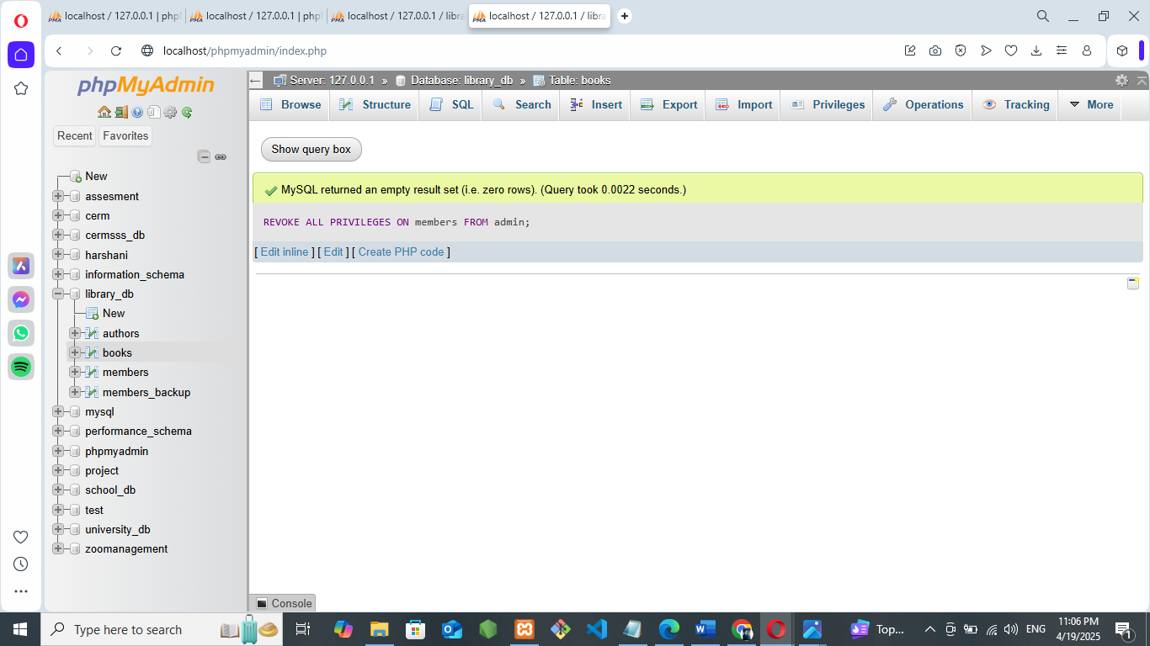

13. Transaction Control Language (TCL)

**LAB EXERCISES**:

• **Lab 3**: Use COMMIT after inserting multiple records into the books table, then make another insertion and perform a ROLLBACK.

Start a transaction (optional in some DBs)

* START TRANSACTION;

Insert multiple records

* INSERT INTO books (book_id, title, author, price) VALUES (101, 'SQL Basics', 'John Doe', 60);
* INSERT INTO books (book_id, title, author, price) VALUES (102, 'Advanced SQL', 'Jane Smith', 95);

Save these two insertions permanently

* COMMIT;

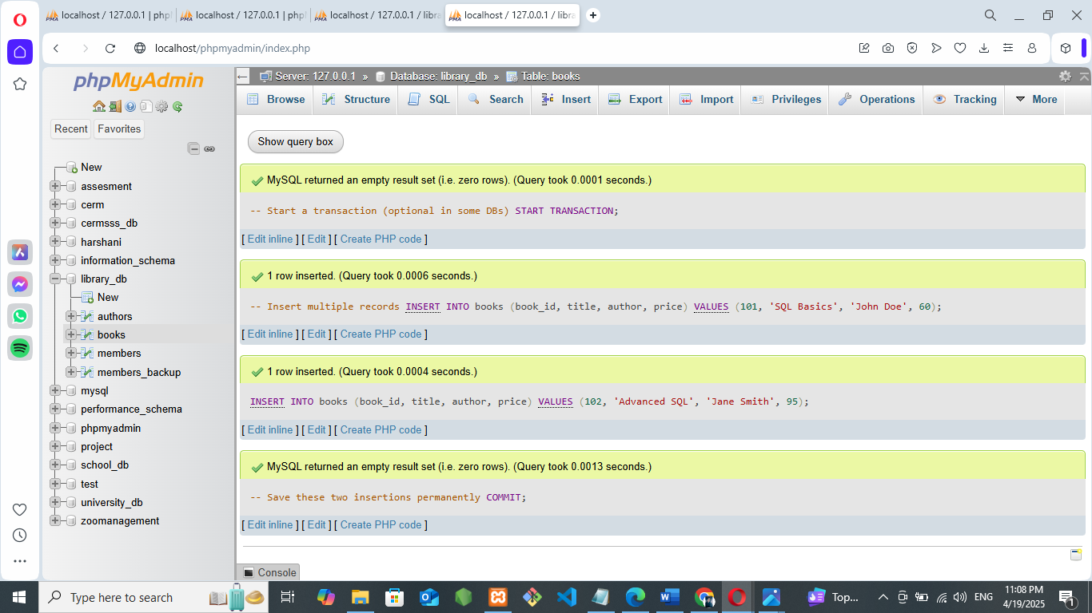

Insert another record

* INSERT INTO books (book_id, title, author, price) VALUES (103, 'Temporary Book', 'MarkLee',70);

Rollback this last insertion

* ROLLBACK;

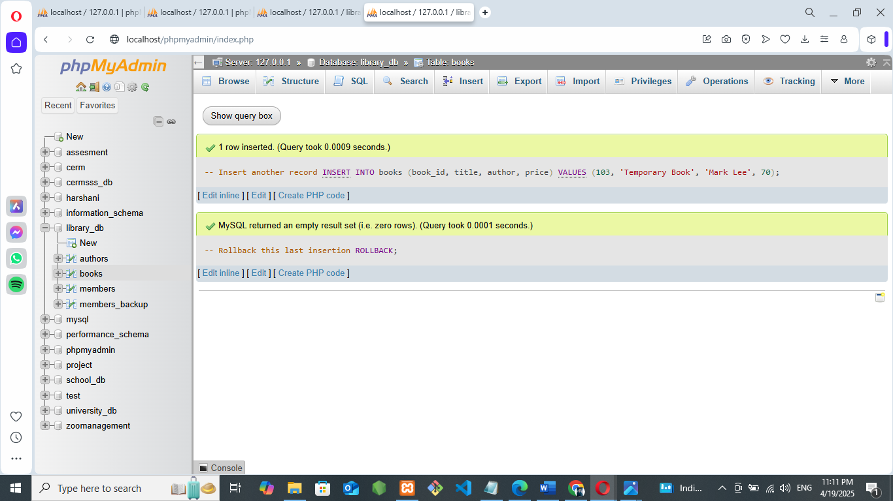

* SELECT * FROM books;

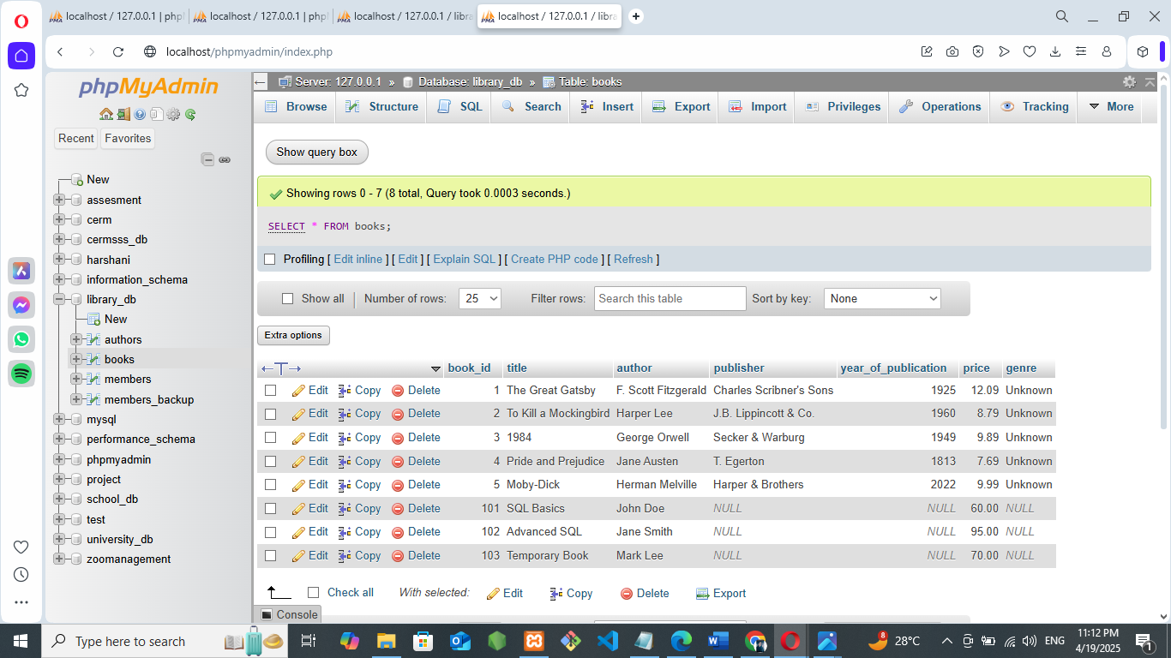

• **Lab 4**: Set a SAVEPOINT before making updates to the members table, perform some updates, and then roll back to the SAVEPOINT.

14. SQL Joins

**LAB EXERCISES**:

• **Lab 3**: Perform an INNER JOIN between books and authors tables to display the title of books and their respective authors' names.

* SELECT books.title AS book_title, CONCAT(authors.first_name, ' ', authors.last_name) AS author_name FROM books

INNER JOIN

authors ON books.author_id = authors.author_id;

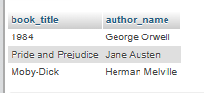

• **Lab 4**: Use a FULL OUTER JOIN to retrieve all records from the books and authors tables, including those with no matching entries in the other table.

* SELECT books.title AS book_title,CONCAT(authors.first_name, ' ', authors.last_name) AS author_name,books.author_id AS book_author_id, authors.author_id AS author_table_id

FROM books

LEFT JOIN authors ON books. author_id = authors.author_id

UNION

SELECT books.title AS book_title,

CONCAT(authors.first_name, ' ', authors.last_name) AS author_name,

books.author_id AS book_author_id,

authors.author_id AS author_table_id

FROM

authors

LEFT JOIN books ON books.author_id = authors.author_id;

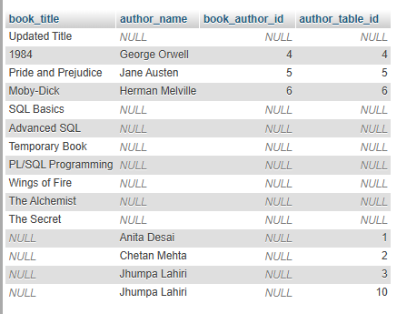

15. SQL Group By

**LAB EXERCISES**:

• **Lab 3**: Group books by genre and display the total number of books in each genre.

* SELECT genre, COUNT(*) AS total_books FROM books GROUP BY genre;

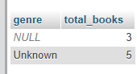

• **Lab 4**: Group members by the year they joined and find the number of members who joined each year.

* SELECT YEAR (date_of_membership) AS join_year,COUNT(*) AS member_count FROM members

GROUP BY YEAR(date_of_membership)

ORDER BY join_year LIMIT 0, 25;

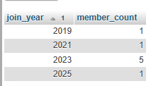

16. SQL Stored Procedure

**LAB EXERCISES**:

• **Lab 3**: Write a stored procedure to retrieve all books by a particular author.

* DELIMITER $$

CREATE PROCEDURE GetBooksByAuthor(IN author_name VARCHAR(255))

BEGIN

SELECT * FROM books WHERE author = author_name;

END $$

DELIMITER ;

* CALL GetBooksByAuthor('John Doe');

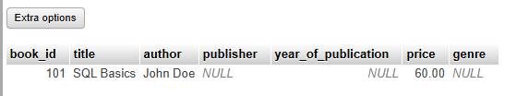

• **Lab 4**: Write a stored procedure that takes book_id as an argument and returns the price of the book.

* DELIMITER $$

CREATE PROCEDURE GetBookPriceById(IN book_id INT)

BEGIN

SELECT price FROM books WHERE book_id = book_id;

END $$

DELIMITER ;

* CALL GetBookPriceById(101);

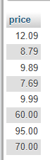

17. SQL View

**LAB EXERCISES**:

• **Lab 3**: Create a view to show only the title, author, and price of books from the books table.

* CREATE VIEW book_details AS SELECT title, author, price FROM books;
* SELECT * FROM book_details;

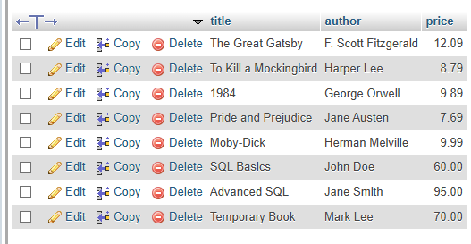

• **Lab 4**: Create a view to display members who joined before 2020.

* CREATE VIEW members_before_2020 AS

SELECT *FROM members WHERE date_of_membership < '2020-01-01';

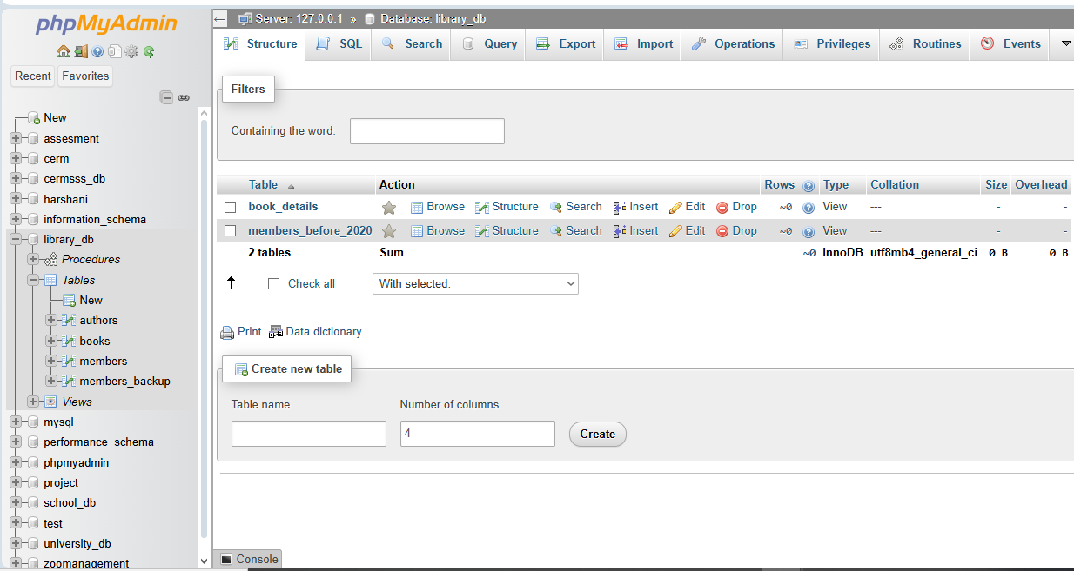

* INSERT INTO members (member_id, member_name, date_of_membership, email)VALUES (7, 'Test User', '2019-12-31', 'test@example.com');
* SELECT * FROM members_before_2020;

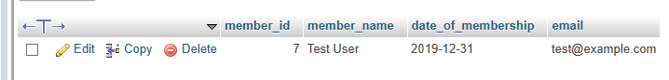

18. SQL Trigger

**LAB EXERCISES**:

• **Lab 3**: Create a trigger to automatically update the last_modified timestamp of the

books table whenever a record is updated.

* ALTER TABLE books ADD last_modified DATETIME;

Create the trigger:

* DELIMITER $$

CREATE TRIGGER update_books_last_modified

BEFORE UPDATE ON books

FOR EACH ROW

BEGIN

SET NEW.last_modified = NOW();

END$$

DELIMITER ;

Test the Trigger:

* UPDATE books SET title = 'Updated Title' WHERE book_id = 1;

Then check:

* SELECT * FROM books WHERE book_id = 1;

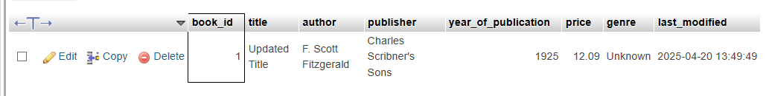

• **Lab 4**: Create a trigger that inserts a log entry into a log_changes table whenever a

* DELETE operation is performed on the books table.

Create the log_changes table:

* CREATE TABLE log_changes (log_id INT AUTO_INCREMENT PRIMARY KEY,book_id INT,title VARCHAR(255), author VARCHAR(255),deleted_at DATETIME);

Create the AFTER DELETE trigger:

* DELIMITER $$

CREATE TRIGGER after_book_delete

AFTER DELETE ON books

FOR EACH ROW

BEGIN

INSERT INTO log_changes (book_id, title, author, deleted_at)

VALUES (OLD.book_id, OLD.title, OLD.author, NOW ());

END$$

DELIMITER ;

### Delete a book:

### DELETE FROM books WHERE book_id = 2;

### SELECT * FROM log_changes;

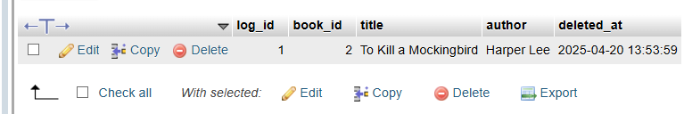

19. Introduction to PL/SQL

**LAB EXERCISES**:

• **Lab 3**: Write a PL/SQL block to insert a new book into the books table and display a confirmation message.

-- Change delimiter to $$ to allow semicolons inside the procedure body

* DELIMITER $$

Create the procedure

CREATE PROCEDURE insert_book(

IN book_id INT,

IN title VARCHAR(255),

IN author VARCHAR(255),

IN publish_year INT

)

BEGIN

Insert a new book into the books table

INSERT INTO books (book_id, title, author, publish_year) VALUES (book_id, title, author, publish_year);

Display a confirmation message

SELECT CONCAT('Book "', title, '" by ', author, ' has been successfully added.') AS confirmation_message;

END $$

Reset the delimiter back to semicolon

DELIMITER ;

* DESCRIBE books;

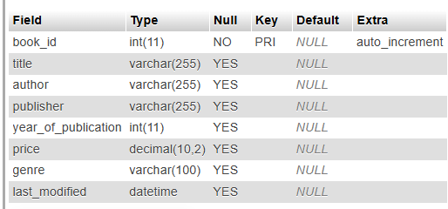

* ALTER TABLE books ADD COLUMN publish_year INT;
* CALL insert_book(201, 'PL/SQL Programming', 'Harshani Patil', 2025);

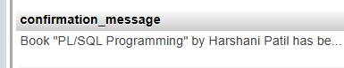

• **Lab 4**: Write a PL/SQL block to display the total number of books in the books table.

* DELIMITER $$

CREATE PROCEDURE get_total_books()

BEGIN

SELECT COUNT(*) AS total_books FROM books;

END $$

DELIMITER ;

* CALL get_total_books();

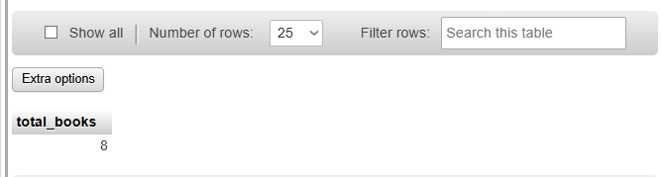

20. PL/SQL Syntax

**LAB EXERCISES**:

• **Lab 3**: Write a PL/SQL block to declare variables for book_id and price, assign values, and display the results.

* DELIMITER $$

CREATE PROCEDURE display_book_details()

BEGIN

Declare variables

DECLARE book_id INT DEFAULT 101;

DECLARE price DECIMAL(8,2) DEFAULT 499.99;

Display results

SELECT CONCAT ('Book ID: ', book_id) AS book_id_message, CONCAT ('Price: ₹', price) AS price_message;

END $$

DELIMITER;

* CALL display_book_details ();

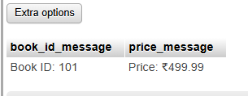

• **Lab 4**: Write a PL/SQL block using constants and perform arithmetic operations on book prices.

* DELIMITER $$

CREATE PROCEDURE book_price_arithmetic ()

BEGIN

Declare constants using variables (MySQL doesn't support true constants in procedures)

DECLARE book_price1 DECIMAL (8,2) DEFAULT 350.75;

DECLARE book_price2 DECIMAL (8,2) DEFAULT 499.25;

Declare result variables

DECLARE total_price DECIMAL (8,2);

DECLARE price_difference DECIMAL (8,2);

DECLARE average price DECIMAL (8,2);

Perform arithmetic operations

SET total_price = book_price1 + book_price2;

SET price_difference = ABS (book_price1 - book_price2);

SET average_price = (book_price1 + book_price2) / 2;

Display results

SELECT

book_price1 AS 'Book Price 1',

book_price2 AS 'Book Price 2',

total_price AS 'Total Price',

price_difference AS 'Price Difference',

average_price AS 'Average Price';

END $$

DELIMITER;

* CALL book_price_arithmetic ();

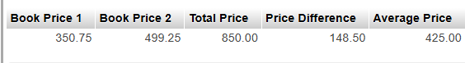

21. PL/SQL Control Structures

**LAB EXERCISES**:

• **Lab 3**: Write a PL/SQL block using IF-THEN-ELSE to check if a book's price is above $100 and print a message accordingly.

* DELIMITER $$

CREATE PROCEDURE check_book_price()

BEGIN

DECLARE book_price DECIMAL(8,2) DEFAULT 120.50; -- You can change this value

IF book_price > 100 THEN

SELECT 'The book price is above $100.' AS message;

ELSE

SELECT 'The book price is $100 or below.' AS message;

END IF;

END $$

DELIMITER;

* CALL check_book_price();

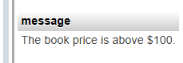

• **Lab 4**: Use a FOR LOOP in PL/SQL to display the details of all books one by one.

-- Ensure this is run separately

* SET FOREIGN_KEY_CHECKS = 0;

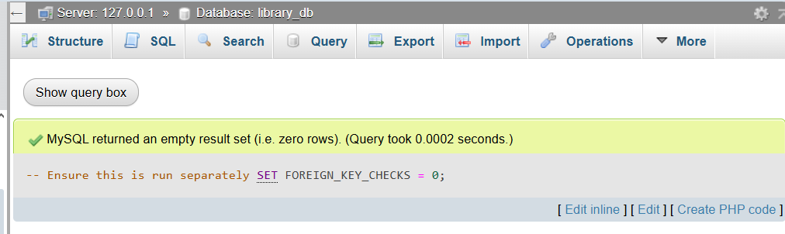

* SET FOREIGN_KEY_CHECKS = 1;

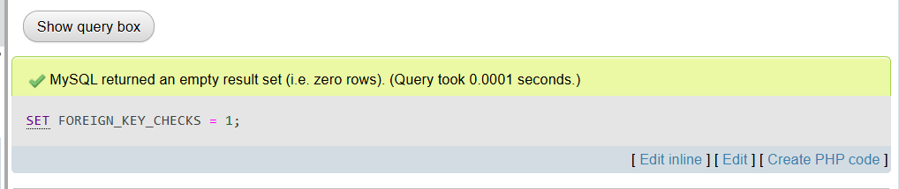

* COMMIT;

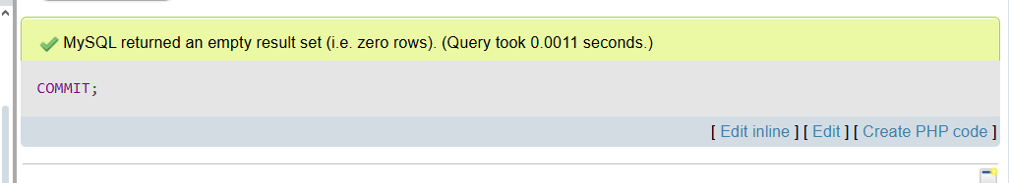

22. SQL Cursors

**LAB EXERCISES**:

• **Lab 3**: Write a PL/SQL block using an explicit cursor to fetch and display all records from the

members table.

* DELIMITER $$

CREATE PROCEDURE FetchAllMembers()

BEGIN

Declare variables to hold column data

DECLARE done INT DEFAULT FALSE;

DECLARE v_id INT;

DECLARE v_name VARCHAR(100);

DECLARE v_join_date DATE;

DECLARE v_email VARCHAR(100);

Declare the cursor

DECLARE member_cursor CURSOR FOR

SELECT member_id, member_name, date_of_membership, email FROM members;

Declare handler for when there are no more rows

DECLARE CONTINUE HANDLER FOR NOT FOUND SET done = TRUE;

Open the cursor

OPEN member_cursor;

read_loop: LOOP

FETCH member_cursor INTO v_id, v_name, v_join_date, v_email;

IF done THEN

LEAVE read_loop;

END IF;

Since MySQL does not support DBMS_OUTPUT, we'll use SELECT to display

SELECT v_id AS 'ID', v_name AS 'Name', v_join_date AS 'Joined', v_email AS 'Email';

END LOOP;

Close the cursor

CLOSE member_cursor;

END$$

DELIMITER ;

* [CALL](http://localhost/phpmyadmin/url.php?url=https://dev.mysql.com/doc/refman/8.0/en/call.html) `FetchAllMembers`();

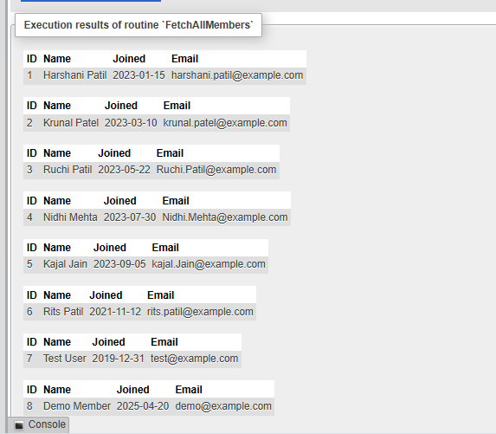

• **Lab 4**: Create a cursor to retrieve books by a particular author and display their titles.

Drop existing procedure

* DROP PROCEDURE IF EXISTS get_books_by_author;

Create the procedure

* DELIMITER $$

CREATE PROCEDURE get_books_by_author(IN author_name VARCHAR(100))

BEGIN

DECLARE done INT DEFAULT 0;

DECLARE book_title VARCHAR(255);

Declare cursor

DECLARE book_cursor CURSOR FOR

SELECT title FROM books WHERE author = author_name;

Exit handler

DECLARE CONTINUE HANDLER FOR NOT FOUND SET done = 1;

Open cursor

OPEN book_cursor;

read_loop: LOOP

FETCH book_cursor INTO book_title;

IF done THEN

LEAVE read_loop;

END IF;

Display the book title

SELECT CONCAT('Book Title: ', book_title) AS result;

END LOOP;

CLOSE book_cursor;

END $$

DELIMITER ;

* CALL get_books_by_author('Harshani Patil');

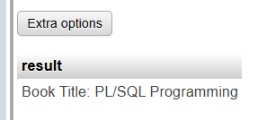

* DESCRIBE books;

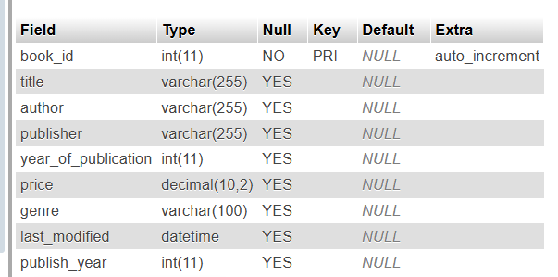

23. Rollback and Commit Savepoint

**LAB EXERCISES**:

• **Lab 3**: Perform a transaction that includes inserting a new member, setting a SAVEPOINT, and rolling back to the savepoint after making updates.

-- Start the transaction

START TRANSACTION;

-- Insert a new member

INSERT INTO members (member_name, date_of_membership, email)

VALUES ('Demo Member', '2025-04-20', 'demo@example.com');

-- Set a savepoint

SAVEPOINT after_insert;

-- Update the newly inserted member's name (this will be undone)

UPDATE members

SET member_name = 'Updated Demo'

WHERE email = 'demo@example.com';

-- Rollback to the savepoint (undo the update)

ROLLBACK TO SAVEPOINT after_insert;

-- Commit the transaction (only the insert remains)

COMMIT;

* SELECT * FROM members WHERE email = 'demo@example.com';

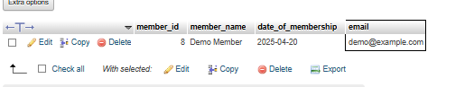

• **Lab 4**: Use COMMIT after successfully inserting multiple books into the books table, then use

ROLLBACK to undo a set of changes made after a savepoint.

-- Step 1: Start a transaction

START TRANSACTION;

-- Step 2: Insert multiple new books

INSERT INTO books (title, author, publish_year)

VALUES

('Wings of Fire', 'A.P.J. Abdul Kalam', 1999),

('The Alchemist', 'Paulo Coelho', 1988),

('The Secret', 'Rhonda Byrne', 2006);

-- Step 3: Commit the successful inserts

COMMIT;

-- Step 4: Start a new transaction to make changes

START TRANSACTION;

-- Step 5: Set a savepoint

SAVEPOINT before_update;

-- Step 6: Perform updates (which we will undo)

UPDATE books SET author = 'Unknown Author' WHERE title = 'The Secret';

UPDATE books SET publish_year = 2025 WHERE title = 'The Alchemist';

-- Step 7: Rollback the updates (back to savepoint)

ROLLBACK TO SAVEPOINT before_update;

-- Step 8: Final commit to save only what came before the savepoint

COMMIT;

* SELECT * FROM books WHERE title IN ('Wings of Fire', 'The Alchemist', 'The Secret');

